**LAB 3 / CSC1310**

**recursion**

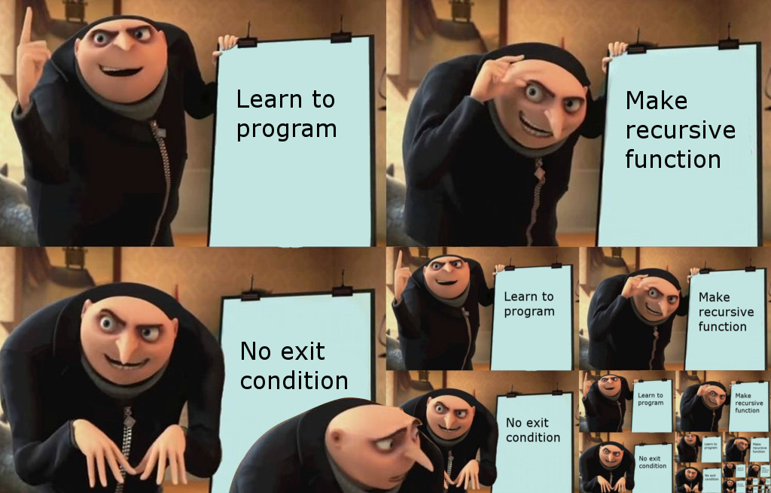

# what should this program do? (specifications)

You will implement 5 **recursive** problems described below and call them from a main function to demonstrate them working**. If you write the functions non-recursively, then you will get no credit for those functions**. All recursive functions could be written non-recursively, but the purpose of this lab is to learn recursion.

## PROBLEM 1: Sum of numbers

Write a function that accepts an integer argument and returns the sum of all the integers from 1 up to the number passed as an argument. For example, if 50 is passed as an argument, the function will return the sum of 1, 2, 3, 4, … 50. **Use recursion** to calculate the sum.

## problem 2: isMember array function

Write a **recursive** Boolean function named isMember. The function should accept three arguments: an array, a value, and the size. The function should return true if the value is found in the array, or false if the value is not found in the array.

## PROBLEM 3: String Reverser

Write a **recursive** function that accepts a string object and the length of the string as its argument and prints the string in reverse order.

## PROBLEM 4: PALINDROME DETECTOR

A palindrome is any word, phrase, or sentence that reads the same forward and backward. Here are some well-known palindromes:

KAYAK

RACECAR

ROTOR

LEVEL

MADAM

MOM

NOON

The main function will take the user’s string and make it all uppercase and also remove all spaces and commas. Then, you should write a bool function **that uses recursion** to determine if the modified user’s string argument is a palindrome. The function should return true if the argument reads the same forward and backward

## Problem 5: Recursive Multiplication

Write a **recursive** function that accepts two arguments into the parameters x and y. The function should return the value of x times y. Remember multiplication can be performed as repeated addition:

7 * 4 = 4+4+4+4+4+4+4

## Main Function

**This function is written for you except for the function calls!!!**

# What to turn in

Please put **Lab3.cpp** in a zipped folder and upload to ilearn submission folder.

# Sample Output

**What do you want to do?**

**1. Sum of Numbers**

**2. IsMember Array Function**

**3. String Reverser**

**4. Palindrome Detector**

**5. Recursive Multiplication**

**6. End the Program**

**CHOOSE 1-6: 1**

**SUM OF NUMBERS**

**Enter an integer: 50**

**The result is: 1275**

**What do you want to do?**

**1. Sum of Numbers**

**2. IsMember Array Function**

**3. String Reverser**

**4. Palindrome Detector**

**5. Recursive Multiplication**

**6. End the Program**

**CHOOSE 1-6: 2**

**ISMEMBER ARRAY FUNCTION**

**Enter an integer: 85**

**Here are the array values: 22 92 98 73 60 31 34 30 94 10**

**No! 85 is NOT in the array.**

**What do you want to do?**

**1. Sum of Numbers**

**2. IsMember Array Function**

**3. String Reverser**

**4. Palindrome Detector**

**5. Recursive Multiplication**

**6. End the Program**

**CHOOSE 1-6: 3**

**STRING REVERSER**

**Enter a string and I will reverse it: April Crockett**

**ttekcorC lirpA**

**What do you want to do?**

**1. Sum of Numbers**

**2. IsMember Array Function**

**3. String Reverser**

**4. Palindrome Detector**

**5. Recursive Multiplication**

**6. End the Program**

**CHOOSE 1-6: 4**

**PALINDROME DETECTOR**

**Enter a string and I will tell you if it is a palindrome: racecar**

**Yes! RACECAR IS a palindrome!**

**What do you want to do?**

**1. Sum of Numbers**

**2. IsMember Array Function**

**3. String Reverser**

**4. Palindrome Detector**

**5. Recursive Multiplication**

**6. End the Program**

**CHOOSE 1-6: 5**

**RECURSIVE MULTIPLICATION**

**Enter in the first integer: 5**

**Enter in the second integer: 9**

**The value of 5 x 9 is 45**

**What do you want to do?**

**1. Sum of Numbers**

**2. IsMember Array Function**

**3. String Reverser**

**4. Palindrome Detector**

**5. Recursive Multiplication**

**6. End the Program**

**CHOOSE 1-6: 6**

**GOODBYE!**